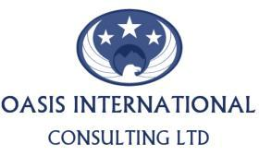

Contact: Kennedy Ben PRESS RELEASE
Tel. +254 721 669055
Email: koasisconsulting@gmail.com
Date: 08/06/2016

1ST ELDORET INTERNATIONAL CONFERENCE ON BUSINESS SCENARIO AND JOBLESS GROWTH
Theme: Business Scenario and Jobless Growth in Emerging Economies; Concerns and Solutions

This is an annual academic conference on the current situation in emerging economies where the situation is people without jobs and jobs without people; Concerns and Solutions.

The Event will take place at Alphax College Uasin Gishu County, Eldoret Kenya on 26th to 28th July 2016 as from 8 am to5 pm. Entrance is free for attending.

Oasis international consulting company is unique firm that has experienced trainers and staff who are able to analyze and assess the needs of the client. The company organizes seminars, conferences and educational Expos in Kenya. The current conference will give every a platform to scholars, researchers, policy makers and all stakeholders to express their ideas and solutions to the increasing jobless growth in emerging economies.

“The immense research work by Africa scholars today is languishing in obscurity because they are not known outside their institutions or region. Besides, African researchers often lack access to foreign journals as most of the universities’ libraries cannot afford to buy these journals anymore” Therefore, we provide a podium where researchers and scholars will publish their scholarly works”.

About Oasis International Consulting Ltd

Oasis International Consulting ltd. started in 2014 with main objective to offer quality service to our clients. We are held high in terms of quality and originality.
To learn more visit www.inteducationexpo.com, or call us at +254 721 66 90 55/+254 786 215 620.]

###

